Questions 0n Artemis Fowl
By: Eoin Colfer

- Who is Artemis Fowl’s Bodyguard?
- What is the name of the centaur?
- What does the LEPrecon Unit send to kill Artemis?
- What does Commander Root smoke a lot?
- What is Artemis Fowl’s Bodyguard’s favourite weapon?
- Who is kidnapped by Artemis Fowl?
- Where does Artemis Fowl live?
- What is the centaur head of?
- Where is the LEPrecon Unit situated?
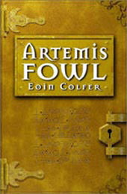
10 What creatures are Holly and Commander Root?

